**Insert:**

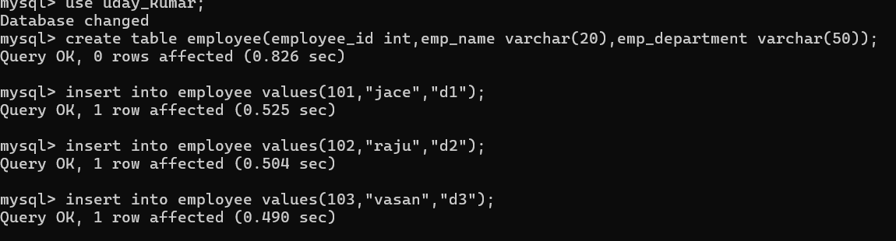

**Select (All columns ):**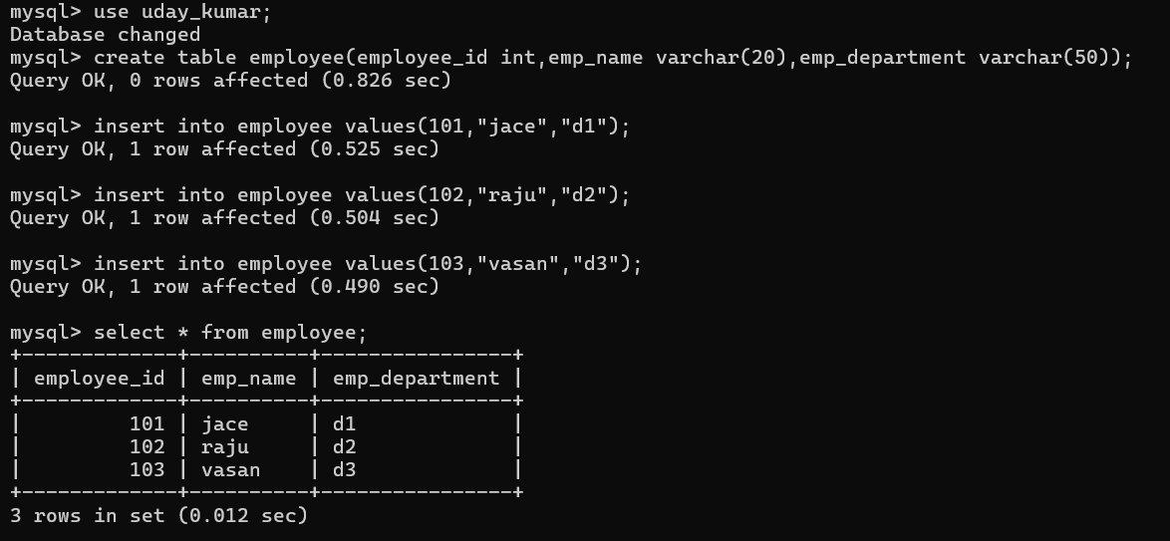

**Select (specific columns):**

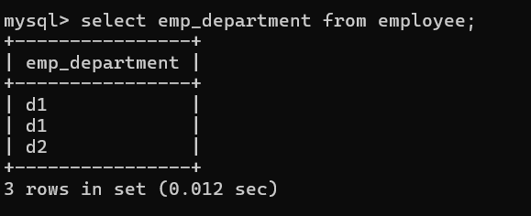

**Select for where clause:**

